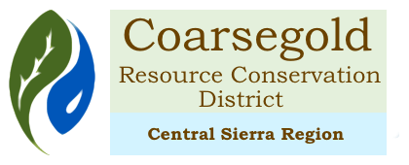

Meeting Agenda for: Friday, October 9, 2020 from 10 am -11:00 am
Zoom meeting
https://zoom.us/meeting/register/tJ0pc-isrz8sH9bGSCcyMOXuC746vuHQR5lK

10:00 Call to Order
Introductions

Approval of the Agenda

Public Comment

10:05 Consent Agenda
Approval of the Minutes of August 14, 2020
Financial reports

10:15 Reports – Please limit to 10 minutes per organization
NRCS – including Civil Rights Discussion - Johnnie Siliznoff
Madera County – Jeannie Habben
Yosemite Sequoia RC & D
Executive Director report

10:45 Old Business
Succession Planning – Additional Staff – Job Listing update
IRWM grant NF Rec Center

10:55 New Business
Smiley Turney contract renewal
CRCD Correspondence
Bills

11:00 Workshops / Events / Presentations
California Forest stewardship Program – on line Nov 3 – Jan 11 $60/person

ADJOURN

